GATE 1 – FUNCTIONAL REQUIREMENTS ENGINEERING
Large-Scale Dataset Profiling & Data Quality Engine
Team 08 | Guide: Mrs. Sneha Varur
Sl. No. | SRN | Student Name
1 | 01FE24BCI046 | Anupriya Savant
2 | 01FE24BCI049 | Pavitra Jalibenchi
3 | 01FE24BCI050 | Anushree Angadi
4 | 01FE24BCI030 | Sahana Awaradi

Section 1: Functional Requirements
FR ID | Description | Priority  (Mandatory/Challenge) | Source Need  (from S0)
01 | The system shall allow users to upload datasets in supported structured/tabular formats and ingest the data for analysis. | Mandatory | Automated profiling
03 | The system shall detect and report common data-quality issues including missing values, duplicate records, data-type inconsistencies, null values and basic invalid values. | Mandatory | Automated detection of common data-quality issues
04 | The system shall analyze the dataset using basic statistics, such as average, minimum, maximum, and distribution, and identify unusual values (outliers). | Mandatory | Unified quality analysis
05 | The system shall display the detected issues and allow the user to select which issues should be corrected. | Mandatory | Automated detection of common data-quality issues
06 | The system shall automatically apply the user-selected corrections, such as correcting supported data types and removing duplicate records, without modifying the original dataset. | Mandatory | Basic recommendations for detected issues
07 | The system shall recheck the corrected dataset and allow the user to perform additional correction rounds until the user chooses to finish and allow to generate quality report. | Mandatory | Unified quality analysis
08 | The system shall provide basic recommendations for suitable corrective actions for detected quality issues. | Challenge | Basic recommendations for detected issues
09 | The system shall support efficient processing of larger datasets within the defined system resource limits. | Challenge | Scalable processing of large datasets

Section 2: Non Functional Requirements
NFR ID | Description | Category | Measurable Target
01 | The system shall process datasets within the supported size limit without failure under the defined test environment. | Performance | Successfully process ≥95% of defined test datasets within the supported size limit
02 | The system should quickly show the user the progress or result while the dataset is being uploaded and analyzed. | Performance | Display processing status within 2 seconds of starting a long-running operation
03 | The system shall preserve the original uploaded dataset without modifying it during quality analysis. | Reliability / Data Integrity | 0 unintended modifications to original input files in test cases
04 | The system shall provide understandable quality results to users through the dashboard. | Usability | A user shall be able to identify the overall score and major detected issues within 1 minute of viewing the results
05 | The system shall provide consistent results when the same dataset and rules are processed repeatedly. | Reliability | Identical input and configuration shall produce identical results in repeated tests
06 | The system shall prevent unauthorized access to uploaded datasets and generated results. | Security | Unauthorized access attempts are rejected in all security tests
07 | The system shall maintain correction results so that users can distinguish the original and corrected datasets. | Reliability | 100% of correction sessions preserve original/corrected distinction

Section 3: Use Cases
ID | Actor | Description / User Story | Main Flow | Exception Flow
01 | User | User wants to upload a supported dataset for quality analysis. | Select file → Upload → System validates file → Dataset accepted. | Unsupported/corrupted/empty file → System displays error and rejects the file.
02 | User | User wants to view the structure and basic characteristics of the uploaded dataset | System reads dataset → identifies rows, columns, data types and basic statistics → Displays profile. | Parsing/type problem → System flags the affected data and continues where possible.
03 | User | User wants to identify problems in the dataset. | System checks missing values, duplicates, invalid values, data-type inconsistencies and outliers → Displays detected issues. | A rule cannot be applied → System marks the issue for review.
04 | User | User wants to choose which detected problems should be corrected. | User reviews issues → Selects corrections → Confirms → System applies selected corrections to a separate copy. | Correction is not applicable/fails → System reports the problem and keeps the affected data unchanged
05 | User | User wants to check the corrected dataset again. | System re-profiles corrected dataset → Runs quality checks → Displays updated results. | New or remaining problems found → System shows them for another correction round.
06 | User | User wants the final quality of the corrected dataset. | User chooses finish → System performs final analysis → Calculates quality score → Generates dashboard and downloadable report. | Report generation fails → System displays error and allows retry.
07 | Admin | Admin wants to manage the rules used for quality checking. | Admin adds/updates/deactivates rules → System validates the rule → Saves the updated rule set. | Invalid/conflicting rule → System rejects the rule and shows the reason.
08 | Admin | Admin wants to control which file formats can be uploaded | Admin adds/enables/disables supported formats → System updates the allowed format list. | Unsupported or invalid configuration → System rejects the change.
09 | Admin | Admin wants to monitor processing and system activity. | Admin views processing status, errors and activity information → System displays monitoring information. | Monitoring data unavailable → System shows an appropriate error/status message.

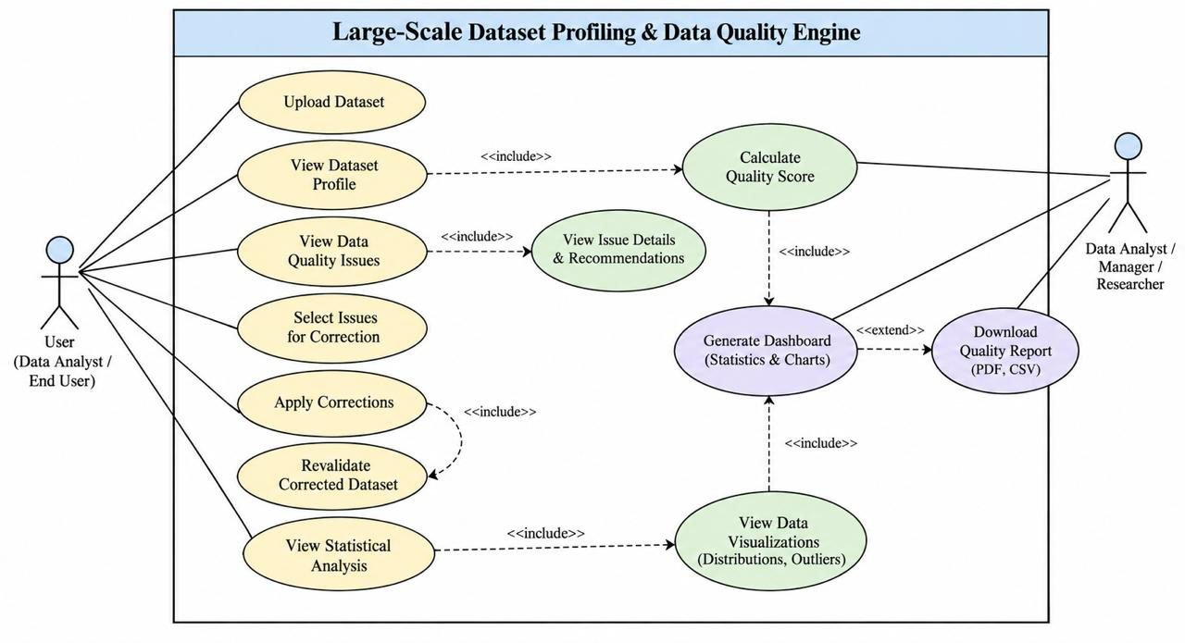
Fig: Use case diagram

Section 4: Acceptance Criteria
Requirement ID | Acceptance Criteria | Test / Verification Method
01 | The system accepts supported dataset files and successfully loads valid files for processing. Unsupported, empty, or corrupted files are rejected with an error message. | Upload valid and invalid test files and verify the result.
02 | The system displays the dataset row count, column count, column names, data types, and basic profile information correctly. | Compare displayed profile results with the known dataset values.
03 | The system correctly detects and reports missing values, duplicate records, data-type inconsistencies, and defined invalid values. | Test datasets containing known quality issues and compare detected results with expected results.
04 | The system calculates the defined statistical measures, identifies applicable outliers, and displays the results correctly. | Run the system on test datasets and compare results with independently calculated values.
05 | The system generates a quality score based on the defined scoring rules and displays the score correctly. | Use datasets with known quality issues and verify the calculated score against the defined formula.
06 | The system displays the detected quality results, final quality score and analysis through the dashboard and generates a downloadable quality report. | Complete the analysis and verify dashboard values and downloaded report values.
07 | The system provides a correction recommendation for supported detected quality issues and the recommendation is relevant to the detected issue. | Create datasets with supported issues and verify the displayed recommendations.
08 | The system processes datasets within the defined supported size/resource limit without failure and completes the quality-analysis workflow. | Test datasets of increasing sizes and measure successful completion and processing time.

